**DATA CENTRIC TESTING ASSESSMENT**

List the count and average salary for employees in department 20.

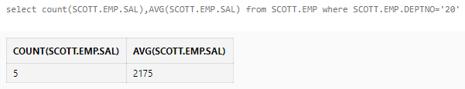

List names of employees who are older than 30 years in the company.

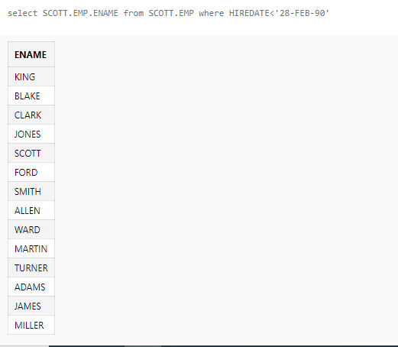

List the employee name , hire date in the descending order of the hire date.

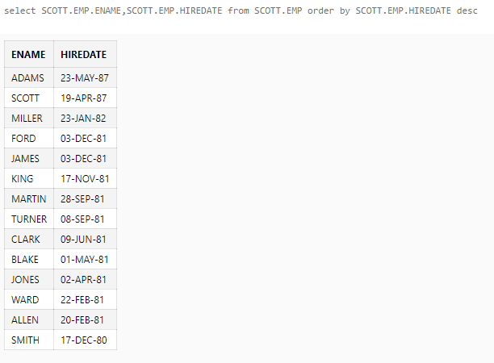

List employee name, department number and their corresponding department name.

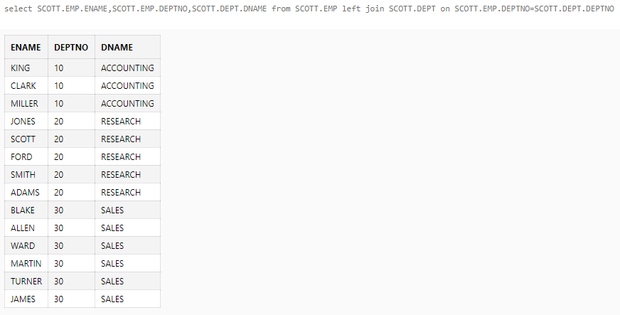

List employee name and their manager name

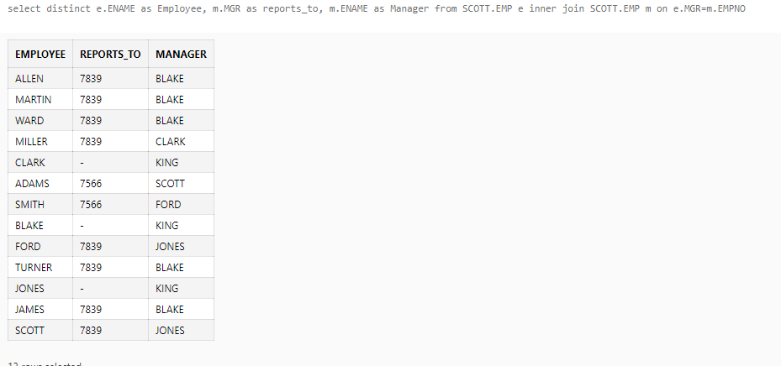

List employees who work in Research department

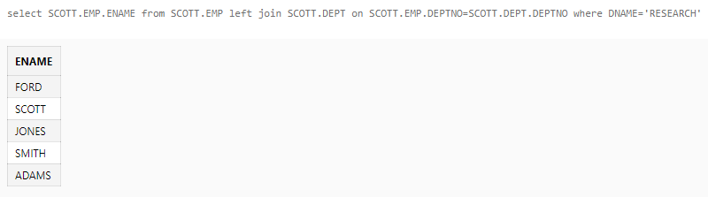

List all rows from EMP table and only the matching rows from DEPT table.

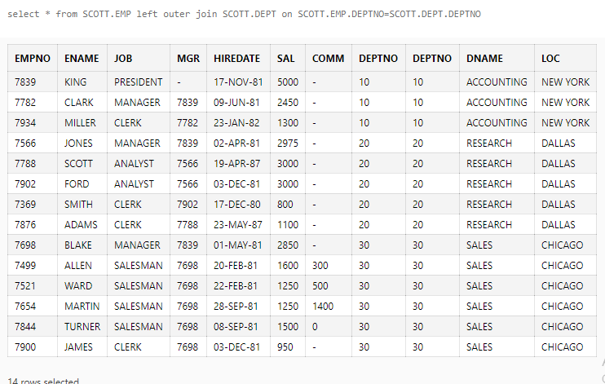

List all rows from EMP table and only the matching rows from DEPT table.



List employees whose job is same as that of Smith

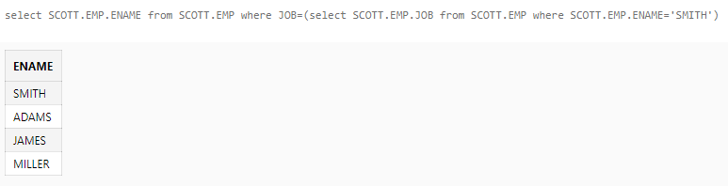

List employees who have joined after Adam

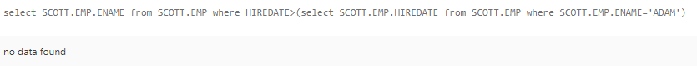

List employees who salary us greater than Scott’s salary

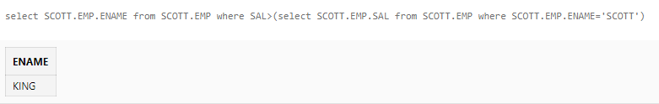

List employees getting the max salary

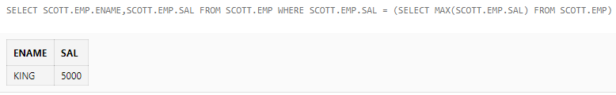

List the maximum salary paid to a salesman

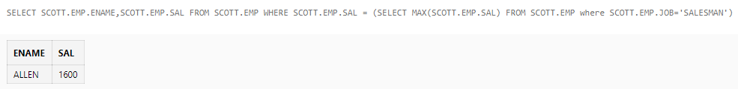

List the total salary, maximum and minimum salary and average salary of the employees, for department 20.

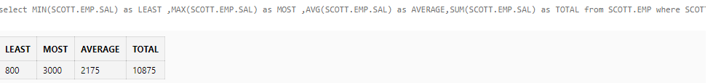

List employees whose job is same as that of Smith

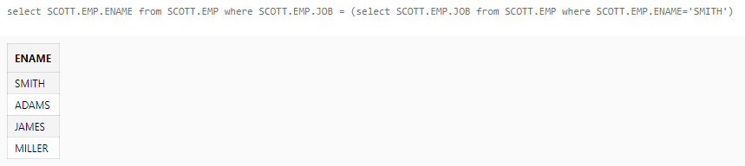

List employee getting the max salary



List all managers

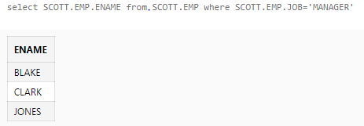

List employees who are not managers

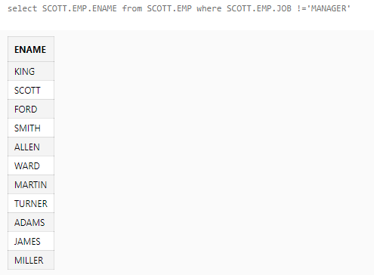

List all employees who earn more than the average salary in their department

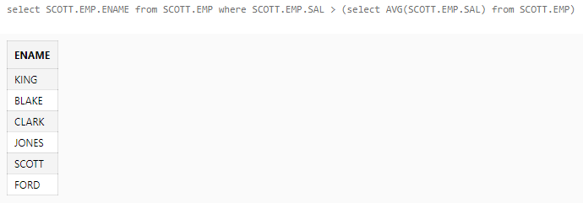

List employees who work in Research department

